KENYA SACCO CREDIT RISK SQL ANALYSIS

create database kenya_sacco_credit_risk_db;
select * from kenya_sacco_credit_risk;
describe kenya_sacco_credit_risk;

CONVERT APPLICATION DATE DATATYPE TO DATE DATATYPE
alter table kenya_sacco_credit_risk
modify column application_date date;

HOW MANY RECORDS DOES THE DATASET HAVE
select count(*) as records from kenya_sacco_credit_risk;
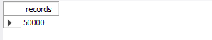
-- The dataset has 50,000 records

COUNT OF TOTAL LOAN APPLICATIONS
select count(*) as total_loan_applications from kenya_sacco_credit_risk;
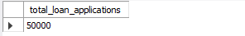
-- The total loan applications within the period were 50,000 applications

COUNT OF UNIQUE BORROWERS
select count(distinct borrower_id) as total_borrowers from kenya_sacco_credit_risk;
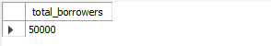
-- There are 50000 unique borrowers from the dataset

HOW MANY BRANCHES DOES THE SACCO HAVE
select count(distinct branch) as branches from kenya_sacco_credit_risk;
select distinct
branch
from kenya_sacco_credit_risk
group by 1;
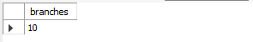
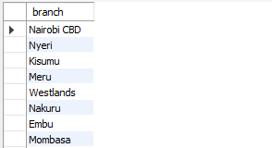
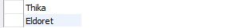
-- The sacco has 10 branches

LOAN APPLICATIONS DATE RANGE
select
min(application_date) as earliest_application,
max(application_date) as latest_application
from kenya_sacco_credit_risk;
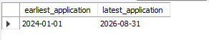
-- Earliest application = 2024-01-01
-- Latest application = 2026-08-31

TOTAL LOAN AMOUNT
select
sum(loan_amount_kes) as total_loan_amount
from kenya_sacco_credit_risk;
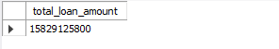
-- The total loan amount is 15,829,125,800

AVERAGE LOAN AMOUNT
select
round(avg(loan_amount_kes), 0) as average_loan_amount
from kenya_sacco_credit_risk;
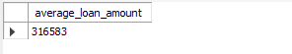
-- Average loan amount is 316,583

MINIMUM AND MAXIMUM LOAN AMOUNT
select
min(loan_amount_kes) as minimum_loan_amount,
max(loan_amount_kes) as maximum_loan_amount
from kenya_sacco_credit_risk;
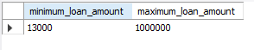
-- The Minimum loan amount applied for = 13,000
-- The Maximum loan amount applied for = 1,000,000

AVERAGE BORROWER INCOME
select
round(avg(monthly_income_kes), 0) as average_borrower_income
from kenya_sacco_credit_risk;
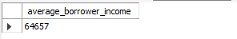
-- The average borrower income is 64,657

TOTAL SAVINGS
select sum(savings_balance_kes) as total_savings from kenya_sacco_credit_risk;
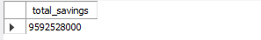
-- The total savings are 9,592,528,000

LOAN PORTFOLIO BY PRODUCT

WHICH PRODUCT HAS THE HIGHEST LOAN APPLICATIONS
select
loan_product,
count(*) as loan_applications
from kenya_sacco_credit_risk
group by 1
order by 2 desc;
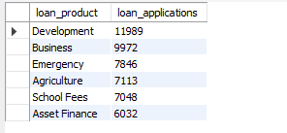
-- Development has the highest loan applications(11,989) then Business(9972), Emergency(7,846 applications) and agriculture(7,113)
-- Asset finance has the least loan applications(6,032)

TOTAL LOAN AMOUNT BY PRODUCT
select
loan_product,
sum(loan_amount_kes) as total_loan_amount
from kenya_sacco_credit_risk
group by 1
order by 2 desc;
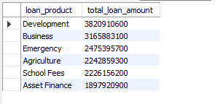
-- The highest loan amount went to development(3,820,910,600)
-- The lowest loan amount went to asset finance(1,897,920,900)

AVERAGE LOAN AMOUNT BY PRODUCT
select
loan_product,
round(avg(loan_amount_kes), 0) as average_loan_amount
from kenya_sacco_credit_risk
group by 1
order by 2 desc;
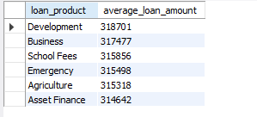
-- Development product had the highest average loan amount(318,701)
-- Asset finance product had the lowest average loan amount(314,642)

TOTAL REPAYMENT AMOUNT BY PRODUCT
select
loan_product,
sum(monthly_repayment_kes) as total_repayment_amount
from kenya_sacco_credit_risk
group by 1
order by 2 desc;
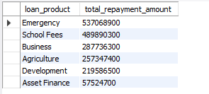
-- Emergency(537,068,900), School Fees(489,890,300), Business(287,736,300), Agriculture(257,347,400), Development(219,586,500), Asset Finance(57,524,700)

AVERAGE REPAYMENT AMOUNT BY PRODUCT
select
loan_product,
round(avg(monthly_repayment_kes),0) as average_repayment_amount
from kenya_sacco_credit_risk
group by 1
order by 2 desc;
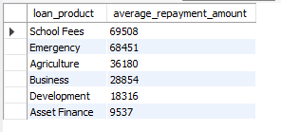
-- School Fees(69,508), Emergency(68,451), Agriculture(36,180), Business(28,854), Development(18,316), Asset Finance(9,537)

LOAN PORTFOLIO BY BRANCH

LOAN APPLICATIONS PER BRANCH
select
branch,
count(*) as loan_applications
from kenya_sacco_credit_risk
group by 1
order by 2 desc;
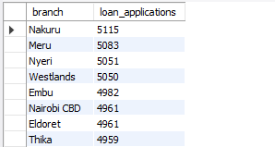


TOTAL LOAN AMOUNT PER BRANCH
select
branch,
sum(loan_amount_kes) as total_loan_amount
from kenya_sacco_credit_risk
group by 1
order by 2 desc;
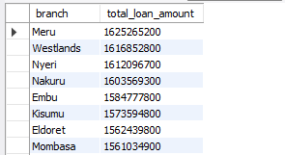
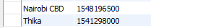

AVERAGE LOAN AMOUNT PER BRANCH
select
branch,
round(avg(loan_amount_kes), 0) as average_loan_amount
from kenya_sacco_credit_risk
group by 1
order by 2 desc;
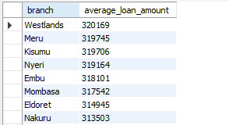

-- GEOGRAPHIC ANALYSIS

TOTAL LOAN APPLICATIONS BY COUNTY
select
county,
count(*) as total_loan_applications
from kenya_sacco_credit_risk
group by 1
order by 2 desc;
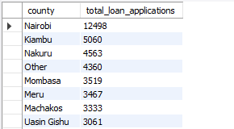
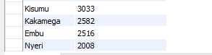

TOTAL LOAN AMOUNT APPLIED PER COUNTY
select
county,
sum(loan_amount_kes) as total_loan_amount
from kenya_sacco_credit_risk
group by 1
order by 2 desc;
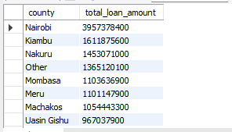
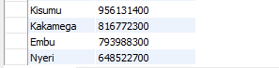

-- EMPLOYMENT ANALYSIS

LOAN APPLICATIONS BY EMPLOYMENT TYPE
select
employment_type,
count(*) as number_of_loan_applications
from kenya_sacco_credit_risk
group by 1
order by 2 desc;
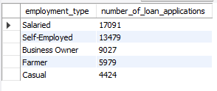

AVERAGE INCOME BY EMPLOYMENT TYPE
select
employment_type,
round(avg(monthly_income_kes),0) as average_income
from kenya_sacco_credit_risk
group by 1
order by 2 desc;
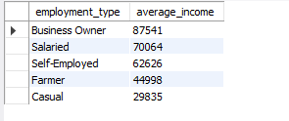
-- business owners and salaried people have the highest average incomes hence they have a higher probability of paying back the loans.

AVERAGE LOAN AMOUNT APPLIED FOR BY EMPLOYMENT TYPE
select
employment_type,
round(avg(loan_amount_kes),0) as average_loan_amount
from kenya_sacco_credit_risk
group by 1
order by 2 desc;
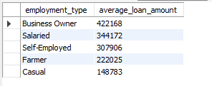
-- Business owners have the highest average loan amount applied for followed by salaried people. This is because business owners and salaried people have the highest average incomes hence they have a higher probability of paying back the loans.

NUMBER OF DEFAULTS
select
count(*) as defaults
from kenya_sacco_credit_risk
where defaulted = 1;
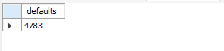
-- Out of the 50,000 loan applications, 4783 loans were not paid back.

NUMBER OF NON DEFAULTS
select
count(*) as non_defaults
from kenya_sacco_credit_risk
where defaulted = 0;
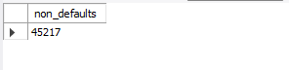
-- Out of the 50,000 loan applications, 45,217 were paid back

DEFAULT RATE
select
round(((count(case when defaulted = 1 then 'default' end) / count(defaulted)) * 100), 1) as default_rate
from kenya_sacco_credit_risk;
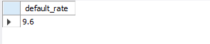
-- The overall default rate is 9.6%

DEFAULT COUNT BY LOAN PRODUCT
select
loan_product,
count(defaulted) as defaults
from kenya_sacco_credit_risk
where defaulted = 1
group by 1
order by 2 desc;
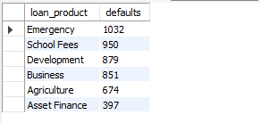
-- Emergency loan product had the highest number of defaults(1032) followed by school fees(950) and development(879)
-- Asset finance product had the lowest number of defaults(397)

DEFAULT RATE BY LOAN PRODUCT
select
loan_product,
count(*) as total_applications,
sum(defaulted) as defaults,
round(avg(defaulted),2) as default_rate
from kenya_sacco_credit_risk
group by 1
order by 4 desc;
